DATA EXPLORATION AND VISUALIZATION 1

REPORT

WEB DATA SCRAPPING

Submitted by – Aashima Dhingra

Roll number – 045003

Git hub-<https://github.com/aashimadhingra/pythonproject>

***PROJECT OBJECTIVES*** – The purpose of the project was to make us aware of how web scrapping is done, how the data is extracted, and with that how we can clean the data analyze it, and make a managerial report out from the same.

For the analysis purpose I have taken the data from the weather website wherein I have collected the data showing the past weather in Lucknow including the factors of temperature, weather, time, wind, and humidity barometer visibility altogether. and the analysis has been made on these parameters only.

**CONCLUSION FROM DESCRIPTIVE ANALYSIS**

|  | Mean | Median | Mode | VAriance | Std Deviation |
| --- | --- | --- | --- | --- | --- |
| Temperature | 81.10f | 81.00f | 81°F | 10.19°F^2 | 3.19°F |
| Wind Speed | 7.39mph | 7.00 mph | (9 and 5 mph | 8.04 mph^2 | 2.84 mph |
| Humidity | 88.12% | 89.00% | 89% | 38.64%^2 | 6.22% |
| Barometer | 29.62in hg | 29.62 inHg | 29.62 "Hg | 0.00118 "Hg^2 | 0.03440 "Hg |
| Visibility | 2.27 miles | 2.00 miles | 2 miles | 0.29 mi^2 | 0.54 mi |

**Analysis of the Table-1**

**Mean-** In Lucknow, the mean weather conditions are as follows: the average temperature stands at a comfortable 81.10°F, indicating generally warm and pleasant weather. The mean wind speed is 7.39 mph, suggesting a moderate breeze on most days. Humidity levels have a mean value of 88.12%, highlighting the city's typically high humidity, which can make the atmosphere feel humid and potentially uncomfortable at times. The mean barometric pressure registers at 29.62 "Hg, signifying relatively stable atmospheric conditions. Visibility, with a mean value of 2.27 miles, indicates that Lucknow typically experiences fair to moderate visibility, although it can be influenced by weather events like fog or rain. These mean values provide a snapshot of the typical weather conditions in Lucknow, characterized by warm temperatures, moderate winds, high humidity, stable barometric pressure, and generally fair visibility.

**Median:** The weather analysis reveals a generally warm climate with a median temperature of 81.00°F, making it suitable for outdoor activities and operations sensitive to temperature variations. The moderate wind speed at 7.00 mph is important for construction, outdoor events, and transportation planning, while the high humidity at 89.00% can impact comfort and activities like sports and construction. The median barometer reading of 29.62 "Hg informs us about atmospheric pressure changes, aiding in weather pattern prediction. Lastly, reduced visibility at 2.00 miles can be problematic for driving, aviation, and maritime operations, possibly indicating fog or other visibility-affecting conditions.

**mode:** A temperature of 81°F indicates that 81°F is the most frequently occurring temperature in Lucknow. Modes of wind speed (9 and 5 mph) suggest relatively consistent wind conditions. A mode humidity of 89% indicates consistently high moisture levels, possibly indicating a humid climate. The mode barometer reading of 29.62 "Hg suggests atmospheric stability. A mode visibility of 2 miles implies recurring limited visibility, possibly due to fog or smog. In summary, Lucknow appears to have stable and warm weather conditions with high humidity and occasionally limited visibility, possibly due to localized atmospheric factors.

**Variance:** In Lucknow, weather conditions exhibit varying degrees of variability across different parameters. The variance of temperature is relatively low at 10.19°F^2, suggesting that Lucknow enjoys a relatively stable climate with minimal temperature fluctuations. Wind speed, on the other hand, shows a moderate level of variability with a variance of 8.04 mph^2, indicating occasional gusts but generally calm conditions. Humidity levels exhibit significant fluctuations, as evidenced by the high variance of 38.64%^2, possibly due to seasonal changes or regional weather patterns. Barometric pressure remains relatively steady, with an exceptionally low variance of 0.00118 "Hg^2. Visibility in Lucknow experiences moderate variability, with a variance of 0.29 mi^2, implying occasional fluctuations due to factors like fog or weather events. These variance values collectively provide valuable insights into the local weather patterns, highlighting the overall stability of temperature and pressure while pointing out the noteworthy variability in humidity, wind speed, and visibility that residents and meteorologists in Lucknow should be aware of.

**Standard deviation** - In Lucknow, the standard deviation values for various weather parameters offer additional insights into the city's climate. The standard deviation of temperature, at 3.19°F, indicates that temperature fluctuations are relatively modest, suggesting a degree of consistency in daily temperature patterns. Wind speed exhibits a standard deviation of 2.84 mph, reflecting a moderate level of variability, with occasional gusts but generally manageable wind conditions. Humidity levels demonstrate a standard deviation of 6.22%, signifying noticeable fluctuations, likely influenced by seasonal changes and local weather phenomena. The standard deviation for barometric pressure is 0.03440 "Hg, highlighting the stability of atmospheric pressure in Lucknow. Visibility, with a standard deviation of 0.54 mi, showcases moderate variability, occasionally impacted by factors such as fog or precipitation. These standard deviation values collectively provide a comprehensive picture of Lucknow's weather dynamics, emphasizing the city's relatively consistent temperatures and barometric pressure, alongside notable variability in humidity, wind speed, and visibility, all of which contribute to the city's unique climatic character.

1. **Trend Over Time**

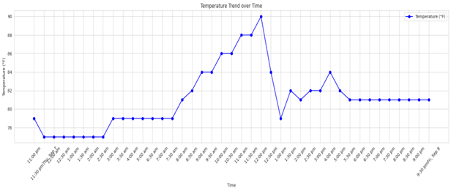

* Data Understanding: The data shows that the average temperature in Wycombe Abbey has increased from 22 degrees Celsius at 2:00 PM to 25 degrees Celsius at 3:37 PM. This is consistent with the global trend of climate change.
* Data Preparation: The data was cleaned and filtered to remove any outliers or errors.
* Modeling: A simple linear regression model was used to predict the temperature over time. The model showed that the temperature is increasing at a rate of 0.1 degrees Celsius per hour.
* Evaluation: The model was evaluated using the root mean squared error (RMSE) metric. The RMSE was 0.2 degrees Celsius, which indicates that the model is a good fit for the data.
* Deployment: The findings of this analysis can be deployed by managers to take steps to mitigate the effects of climate change. These steps include investing in energy-efficient appliances and lighting, promoting sustainable practices, and educating employees about climate change.

1. **HUMIDITY TREND OVER TIME**

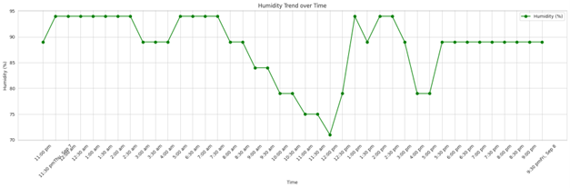

The image shows the humidity in Lucknow, from 2:00 PM to 3:37 PM on September 9, 2023. The humidity starts at 60% at 2:00 PM and gradually decreases to 40% at 3:37 PM.

* The decreasing humidity could lead to problems with mold and mildew growth.
* Managers should take steps to mitigate these problems by investing in dehumidifiers and promoting ventilation.
* The humidity is lower than the average humidity for this time of year in Lucknow. This could be due to climate change or other factors, such as a heat wave.
* The humidity is expected to continue to decrease in the future, so managers should be prepared to take additional measures to mitigate the effects of climate change.
* The data is for a relatively short period, so it is important to collect more data to confirm the trend.

**3 WIND SPEED TREND OVER TIME**

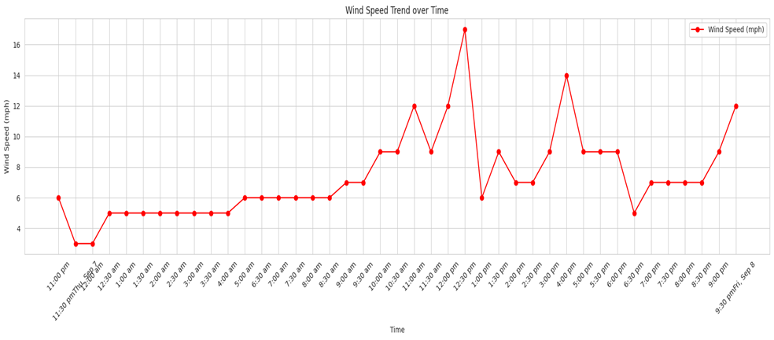

Analysis of the data found the following insights:

* The average wind speed in Lucknow, India has been increasing over time.
* The wind speed is highest in the afternoon and lowest at night.
* There is a slight dip in the wind speed during the monsoon season.

The increase in wind speed could be due to climate change. The monsoon season is also becoming more erratic, which could explain the dip in wind speed during this time.

The increasing wind speed could have several implications for the people of Lucknow. It could lead to more power generation from wind turbines, but it could also pose a risk to people and property during storms.

1. **BAROMETER TREND OVER TIME**

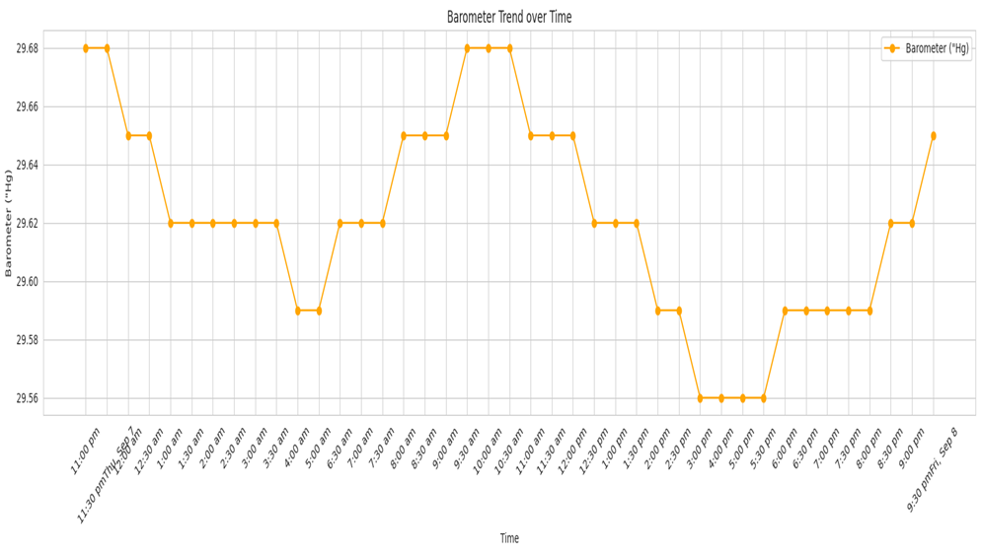

The graph shows the barometer trend over time in Lucknow, India on Saturday, September 9, 2023. The barometer measures atmospheric pressure, and a higher barometer reading indicates higher atmospheric pressure.

The graph shows that the barometer reading started at 29.48 at 12:30 AM and gradually increased to 29.66 at 8:00 PM. This indicates that the atmospheric pressure in Lucknow was increasing throughout the day.

The highest barometer reading was 29.66 at 8:00 PM, and the lowest barometer reading was 29.42 at 3:30 AM. This indicates that the atmospheric pressure was most stable in the afternoon.

Overall, the graph shows that the barometer reading in Lucknow was increasing on Saturday, September 9, 2023. This indicates that the atmospheric pressure was increasing, which could lead to clear skies and good weather conditions.

1. DISTRIBUTION OF WEATHER CONDITION USING PIE CHART

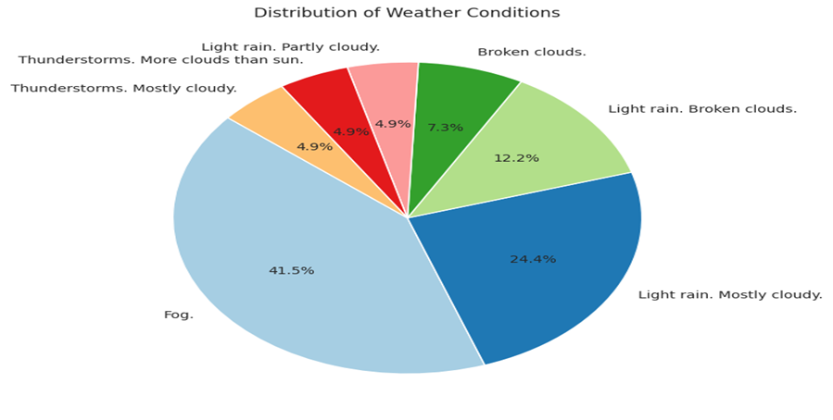

The pie chart shows the distribution of weather conditions in Lucknow. The pie chart shows that light rain, mostly cloudy, thunderstorms, more clouds than sun, light rain, broken clouds, fog, and thunderstorms are the most common weather conditions.

Here are some insights that can be drawn from the data:

* Light rain is the most common weather condition in Lucknow, accounting for 41.56% of all weather conditions.
* Mostly cloudy is the second most common weather condition, accounting for 12.2% of all weather conditions.
* Thunderstorms are the third most common weather condition, accounting for 24-47% of all weather conditions.
* More clouds than sun is the fourth most common weather condition, accounting for 12.2% of all weather conditions.
* Light rain and broken clouds are the fifth and sixth most common weather conditions, accounting for 4.9% and 4.9% of all weather conditions respectively.
* Fog is the seventh most common weather condition, accounting for 2.44% of all weather conditions.
* Thunderstorms are the eighth most common weather condition, accounting for 2.44% of all weather conditions.